**Daily Scrum or Standup Meeting**

Team name: Alpha Squad

Scrum Master: Alex Beeston

Date: October 30, 2019

|  |  |  |  |
| --- | --- | --- | --- |
| **Team Member** | **What did you do since the last scrum?** | **What do you plan to do before the next scrum?** | **What obstacles do you have?** |
| Alex Beeston | I got the virtual environment set up on my computer, I learned about how to handle database migrations, and I started working on the live auction admin page. | Create functionality for an admin to enter an item into the live auction database of items. | None. |
| Joey Carlisle | Got the Users working, fixed the rules page, and removed a lot of junk. | Work on the create items functionality | Potentially the models may be a hold up. |
| Isaak Johnson | I made a few example items and made it so they show up on the silent auction page, each with a bidding form. | Linking a bid to an item and a user, and sorting items on the silent auction page by bid on, winning the bid, and not bid on. | Not totally sure how to do it yet. |
| Ben Taylor | Attempted to assist Joey, so not much. | Get the Users page and payment page working. | None |

# Burndown

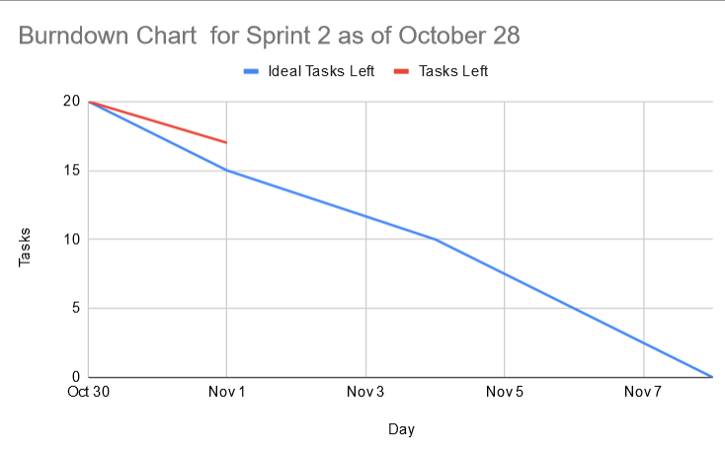

# Screenshot of you project board

